Assignment 2: Programming in Python CST 362

Name: **Alby Thekkedan Roll No 8 Class CS6B**

KTU-ID: **MDL20CS129**

Date of submission: 06-March-2023

**Learning outcome: Learn to use loops, nested loops and strings**

1. 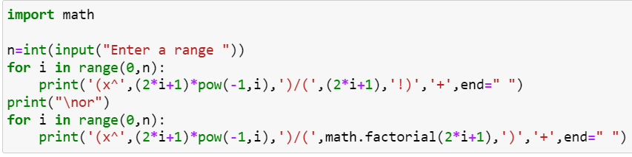Print the sin series x-x^3/3!+x^5/5!. x^n/n! ( read n)

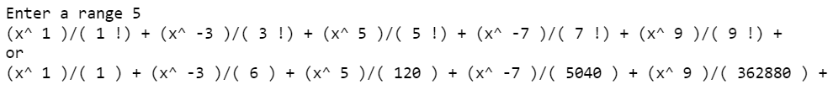

1. 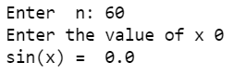 In the above program read the value x and find the sum of the series.

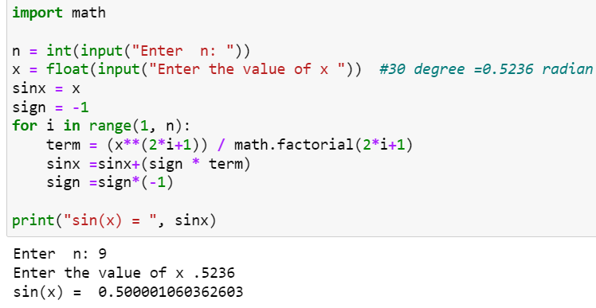



1. 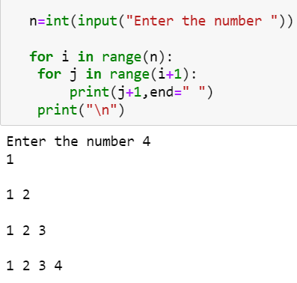
2. The pyramid is given for n=4 do this for any n

1 2

1 2 3

1 2 3 4

1. 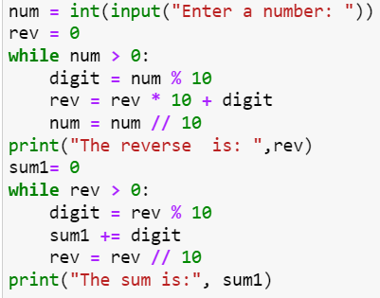Reverse a number and also find the sum of the digits Eg: i/p : 546 o/p:reverse=645 sum=15

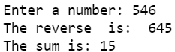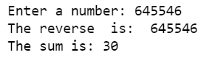

1. 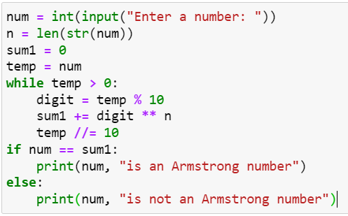**Armstrong numbers**



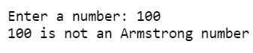

1. Find the square root of a number using Newton’s method

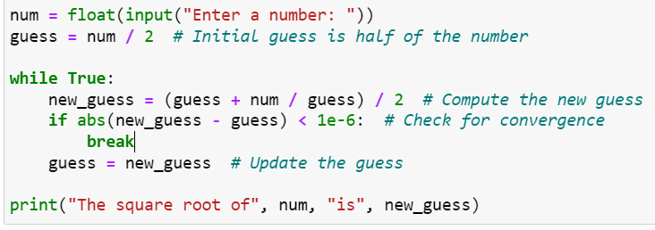



1. Write a program that computes an investment report.

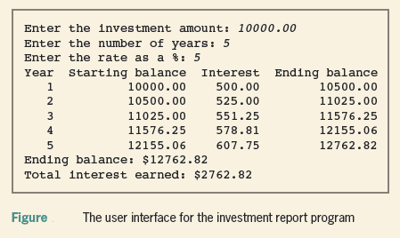

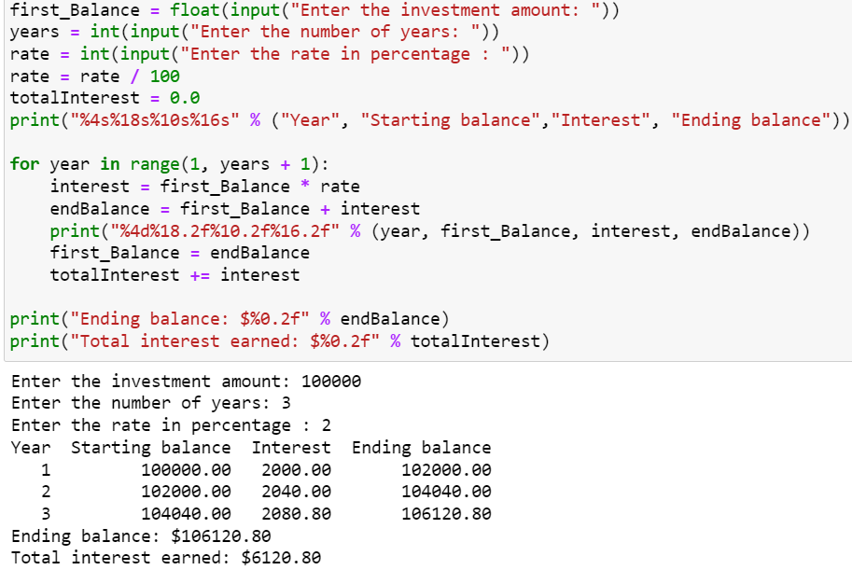



1. Check whether the given number is a Krishnamurti number (.Use factorial () function from math) For example: 145 = 1! + 4! + 5! = 1 + 24 + 120 = 145 is a Krishnamurthy Number

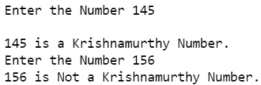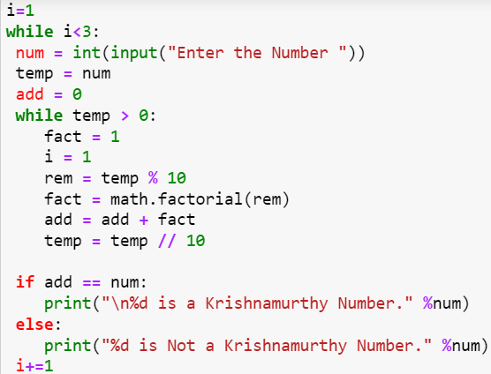

1. Find the sum of the first and last digit of a number( i/p:354 o/p=3+4=7)

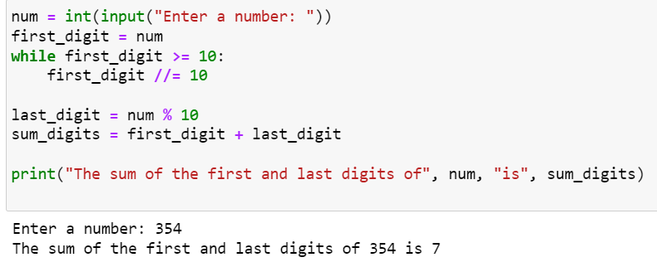



1. Input a number and print it in words ( i/p:345 o/p: Three Four Five)

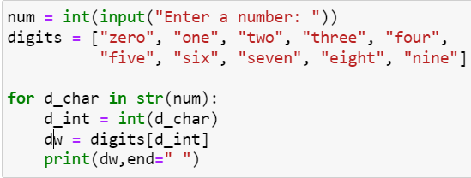



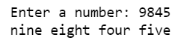

**Strings**

**Outcome: Learn String Indexing and slicing, programming with strings**

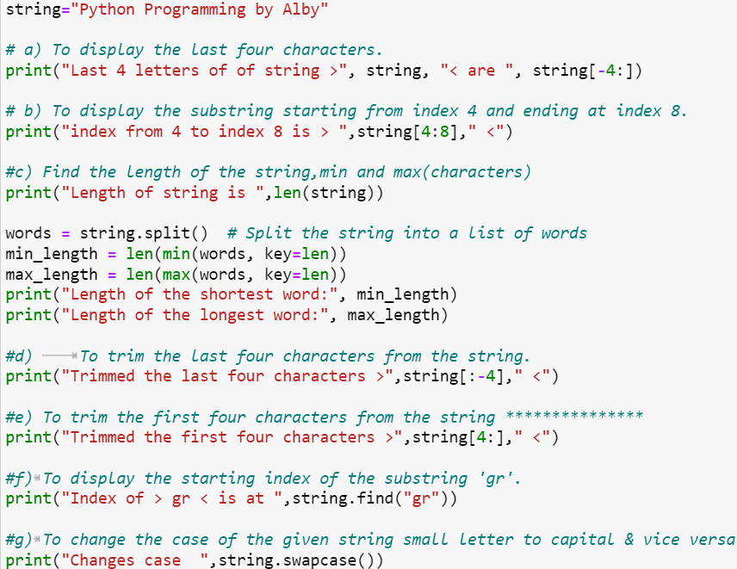**Consider the string str="Python Programming by Alby" .Write statements in python to implement the following**

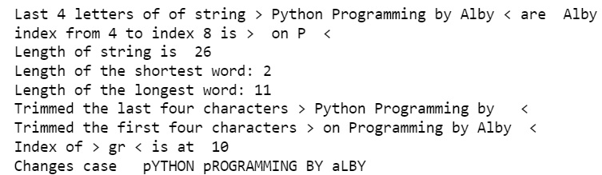

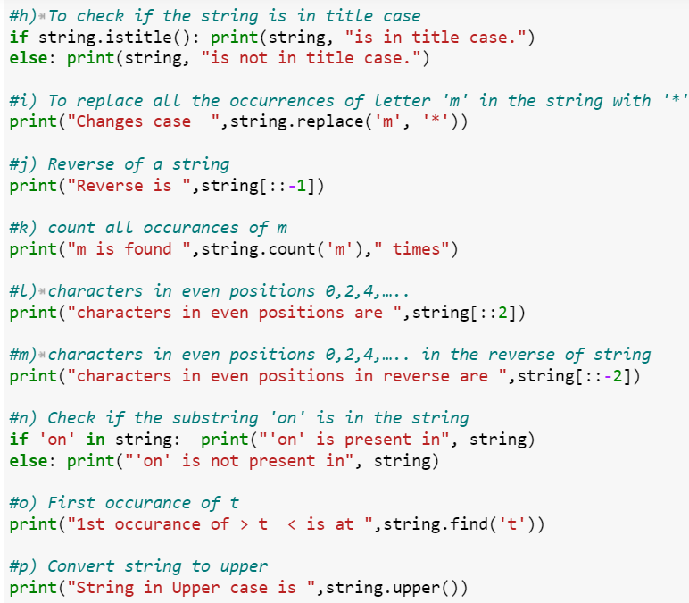

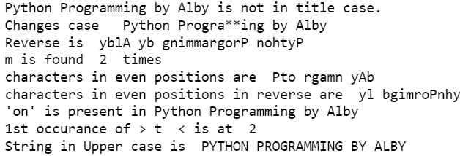

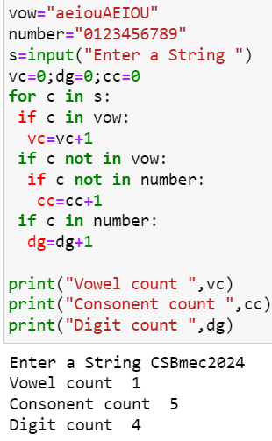2. Write a program to check whether the given string is palindrome or not.

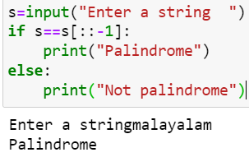

3. Count the vowels, digits, consonents, spaces in a string.



4. Read a binary number as a string and find its corresponding decimal

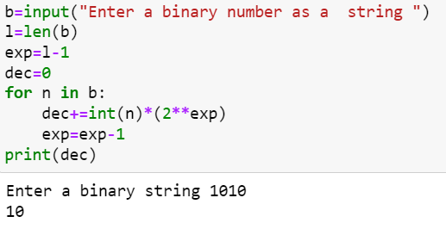

5. Read a decimal number and find its binary.( Hint: divide by 2 and append the reminder to a string)

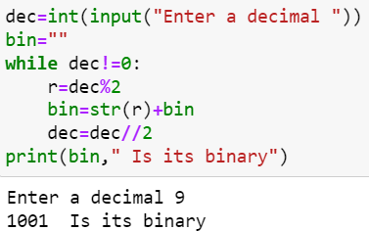



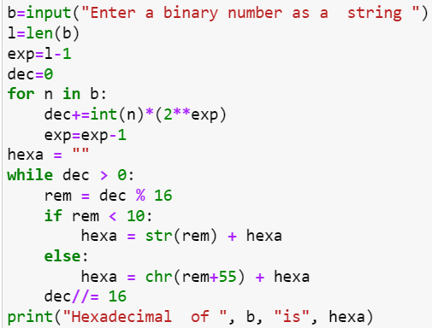6. Read an 8 bit binary number and print the hex equivalent





7.Read a two digit hex number and print the binary and decimal equivalent.

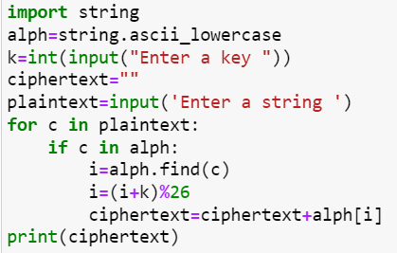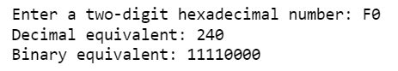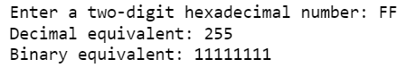 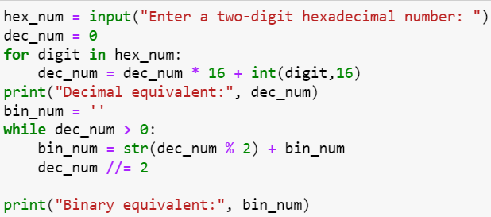

8. **Encrypt a string using the shift cipher( key=3 Ceaser cipher)**

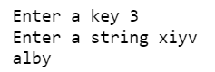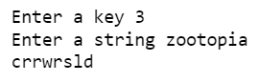

9.Write a Python program to check the validity of a password given by the user. The Password should satisfy the following criteria: Contains at least one letter between a and z, number between 0 and 9,letter between A and Z, special character from $, #, @ 5.Minimum length of password: 8

|  |
| --- |
|  |